**Photometric Stereo**

In this assignment, I used 21 images for each object to get their normal map linearly encoded in RGB, albedos and their re-rendered pictures.

My calculating process can be generated as bellow:

(1) Read 21 images and transfer their data to Mat format (function Readstring & function Transfer)

(2) Recorded every pixel value and formed their RGB value as Intensity matrix (function Calpix)

(3) Calculated light intensity of ever image through the brightest point on the Lambertian sphere and take its  **** as 1 (function CalLam)

(4) Calculated the illumination direction of ever image through the brightest point of the right metal sphere and its radium (function CalBPoint & function CalCenter & function CalL)

L=2(N.R)N-R

Nx=BPx-Cx;

Ny=BPy-Cy;

Nz=sqrt(R^2-Nx^2-Ny^2);

[ Taken R as (0,0,1) ]

(5) Calculated the albedo and the surface normal for every point on the object(function CalG)

G= invert ( tranverse(L)*L)*tranverse(L)*I

kd = ||G||

N =G/kd

**Result**

**(**RGB, albedo and re-rendered pictures are arranged from left to right**)**

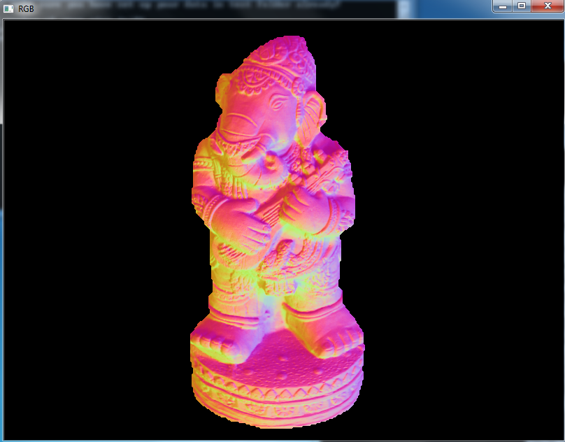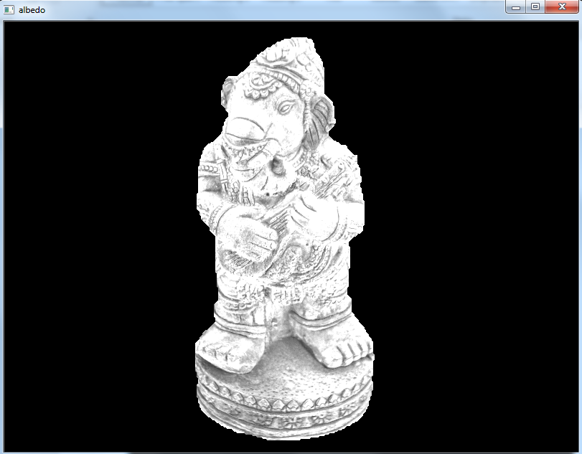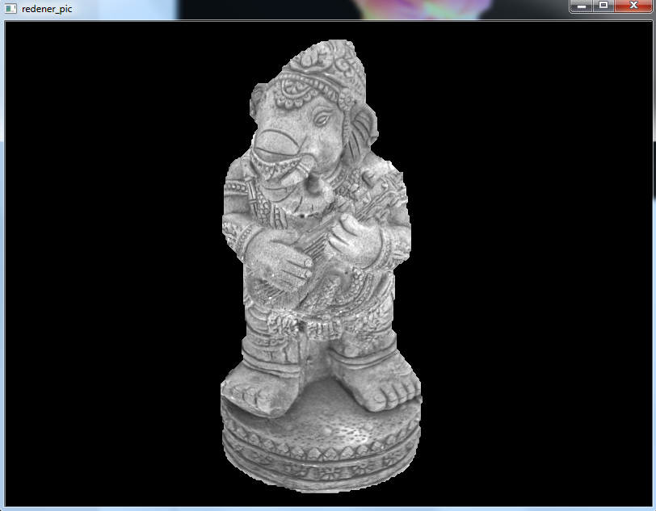

Elephant RGB elephant albedo elephant re-rendered

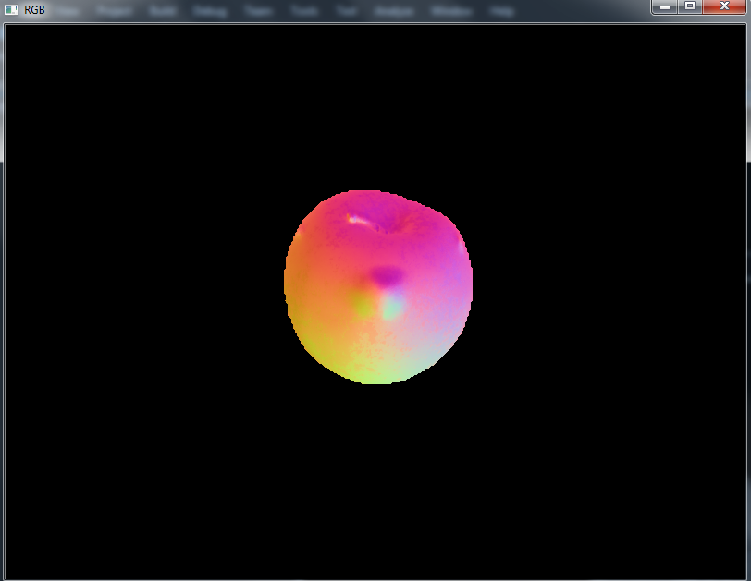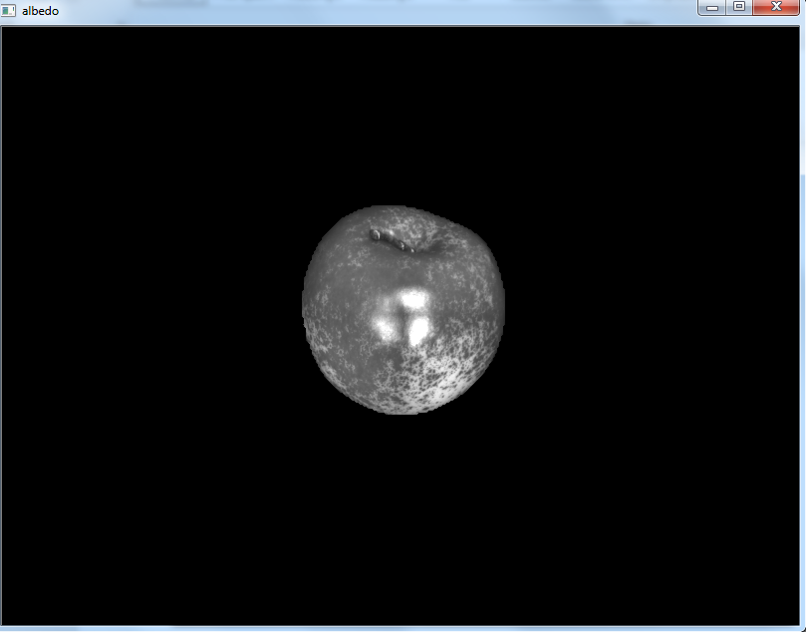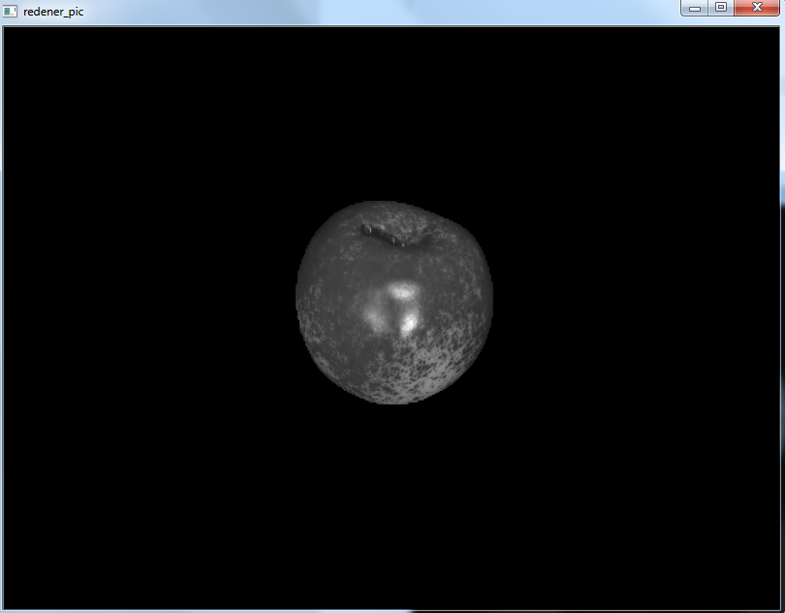

Apple RGB apple albedo apple re-rendered

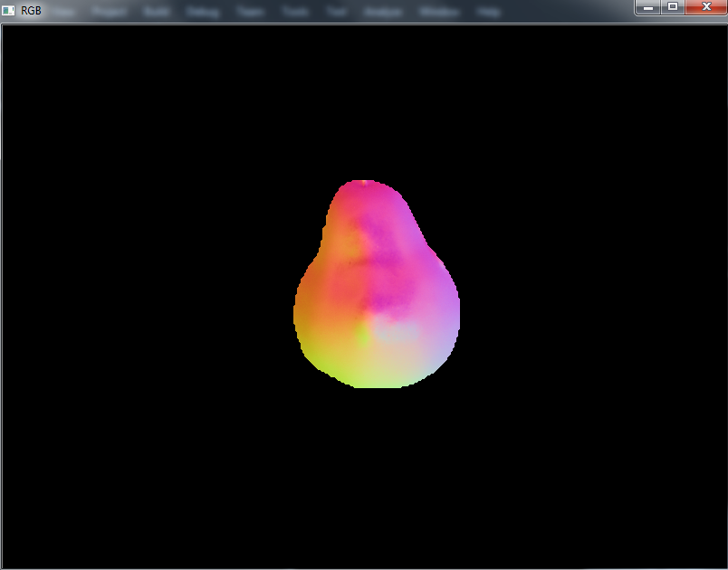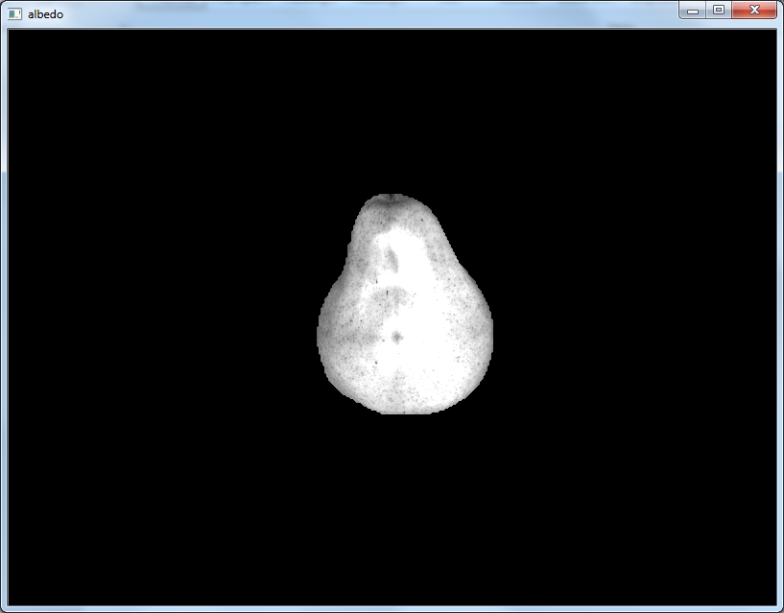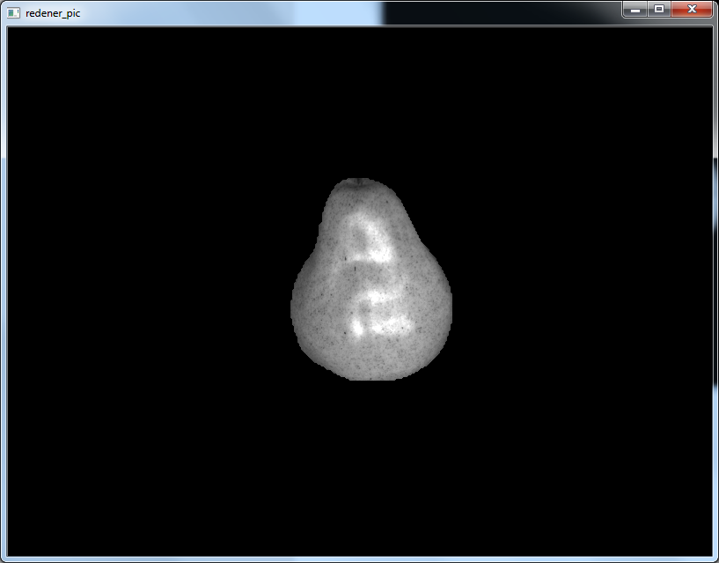

Pear RGB pear albedo pear re-rendered

**Discussion**

Following the experiment, I found the shadow points will influence the result of the experiment a lot. However, due to a relatively big amount of data (21 pics) I have, the shortcoming which result from shadow points in every image will be made up. From this view, I think the dataset which contains less shadow points in every pictures and have large amount of images will be appreciate. As for my algorithm, I did not take different image’s Intensity for every pixel as a whole matrix firstly, as a result I use the function: Readstring and Transfor twice in the loop. There is definitely a waste of program’s running time. Next time I will consider this problem before begin to program on the computer.